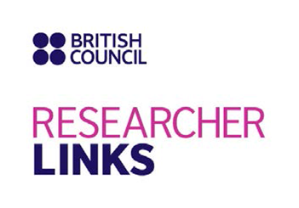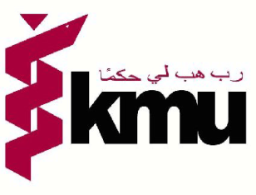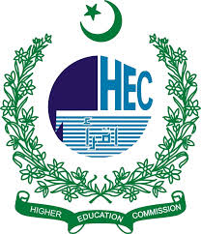

NUTRITION POLICY TO PRACTICE IN PAKISTAN: EXPLORING THE CHALLENGES AND RESEARCH OPPORTUNITIES
A HIGHER EDUCATION COMMISSION PAKISTAN & BRITISH COUNCIL FUNDED RESEARCHER LINKS WORKSHOP

UK Coordinator: Prof. Nicola Lowe
Pakistan Coordinator: Prof. Dr. Mukhtiar Zaman
Discipline: Nutrition
Date of the event: March 8-11, 2015.
Venue: Serena Hotel Islamabad

APPLICATION FORM (Only for Pakistani Citizens)

Serial No._______________

1. PERSONAL DATA

Name:_________________________________________________________________________
Father’s / Husband’s Name:_______________________________________________________
Date of birth (dd/mm/yy):__________________Gender: M F
Place of birth:___________________Domicile:______________________________________
Mailing Address:_______________________________________________________________
__________________________________________________________________________________________________________________________________________________________________________________________________________________________________________
Phone: (Res)______________________________Cell:_________________________________
Email:_________________________________________________________________________
Permanent Address: _____________________________________________________________
____________________________________________________________________________________________________________________________________________________________
Current Designation______________________________________________________________
Name of Institution_______________________________________________________________

2. ACADEMIC QUALIFICATIONS:

Name of Institutions | City, Country | Received Dates | Title of Degree Received | Marks Obtained / CGPA | Total Marks / CGPA | %
3. COMPUTER PROFICIENCY (√ or X)

Email & Internet
Microsoft Word
Microsoft Power point
Microsoft Excel

4. PROFESSIONAL EXPERIENCE:

Name of Institutions | Major Responsibilities | Position | Dates Employed

5. CERTIFICATES/WORKSHOPS/SEMINARS/CONFERENCES ATTENDED:

(Use additional sheets if required)

Name of Institution/  Organization | Type of Course | Dates Attended | Title of the Course

6. RESEARCH EXPERIENCE (Publications)

Attach as Annexure 1 with the application form in the tabulated format as given below;

S. No | Authors | Title of Publication | Name of Journal with Impact factor | Year/Volume/Issue

Abstract: Please give a summary of your area of Research

7. STATEMENT OF PURPOSE (Describe in not more than 250 words your motivation to attend the workshop and how the workshop matches your professional development needs

8. Please describe the expected impact of your participation to the workshop on your personal and professional development, including your ability to work on an international level

9. Please indicate how you will disseminate the outcomes of the workshops and the new knowledge/skills you have acquired

10. Workshops will take place in English as standard. Please indicate your ability to work and communicate in English;
Native speaker | Good
Excellent | Need support

11. Please use this space to give any additional information that you feel is relevant for the application.
12. DECLARATION: Certified that the facts produced are correct to the best of my knowledge.

Signature of the Applicant:__________________ NIC:___________________________________

Signature of the Head of Institute with official stamp:_______________________________________________

IMPORTANT NOTE / INSTRUCTIONS

Applicants must attach with application form the following documents:

Note: Check (√) the relevant box for the attached documents.

Copy of Degrees (attested)

Copy of CNIC

One passport size colored photograph of the applicant.

Detailed CV

Abstract of not more than 500 words in the relevant subject of nutrition (see advertisement for details) which will be presented during the workshop. (Attach as annexure II)

- All applicants must appropriately fill and sign the application form and should be forwarded with a covering letter from head of the institute / University.
- Applications should reach office Research Innovation & Commercialization KMU till 30th January 2015 before the closing of office hours.
- Application forms with any false statement by the candidate will be rejected.

ADDRESS:

Office of Research, Innovation & Commercialization (ORIC), Khyber Medical University, Block IV, PDA Building, Phase V, Hayatabad, Peshawar, Khyber Pakhtunkhwa, Pakistan

For further details about the workshop visit website: www.kmu.edu.pk

OR Contact

Dr. Zeeshan Kibria (Manager Research & Development ORIC KMU) at 091-921-7258,
email: zeeshankibria@yahoo.com

